Erasmus+ Project
“#respACT – Activating VET teachers to counter hate speech and cyberbullying”
n° 2020-1-DE02-KA202-007716

#respACTescapegame

This work is licenced under

The European Commission support for the production of this publication does not constitute an endorsement of the contents which reflects the view only of the authors, and the Commission cannot be held responsible for any use which may be made of the information contained therein.

Background information
Why use an escape room with your group to address school related themes or in this case civic education themes?
Countering Hate speech and cyberbullying were the main themes of your project #respACT. Escape rooms are becoming increasingly popular. They allow groups to enter a limited, thematically and scenically designed room for a short time from which they can free themselves by solving puzzles or in which they have to complete a task. This playful format can be used to explore almost any topic with a high degree of player’s involvement. Escape Rooms offer an experience in a safe environment. Game fun is combined with civic/political education. In line with the themes of the project, we decided to focus our escape game on the theme of cyberbullying.
We also wanted to create a very simply escape game, which does not require any expensive equipment and which teachers and trainers can play with their groups without having to spend a lot of time for the preparation. At the same time, we wanted the game to be easily adaptable to your groups and settings.

Necessary equipment:
- Classroom with tables, chairs etc. (we have set the scene in a classroom in order to make it more realistic for the students)

- Student backpack containing books etc.
- 2 or better several jackets with pockets
- Printed version of a seating plan of the classroom. Mark each seat with a name, two of these names should be Anna & Alex (the two missing students). The word ‘seating plan’ should be in the top and you should be able to tear off the bottom part (seating plan).
- Waste bin
- Bulletin board or similar (something to attached different pieces of information; if you do not have a bulletin board, then use the inside of the classroom door)
- Calendar / diary with padlock (Lock the calendar with a small padlock. If you cannot find a suitable calendar or diary, you can simply use an exercise book, put holes through it, and insert a padlock)
- UV marker & light/lamp (to write secret messages)
- An email address, set up for this game. Please create an email address and set up an automatic response.
- A device from which the students can send an email. If for some reason, this is not possible. Print the email and explain to the students that if they need to access a laptop, phone or similar, that they should ask you. Then hand them the printed email.
- A device with which the students can scan a QR code. (Create a QR code for a local doctor’s office; the idea is that one of the students is actually at a doctor’s appointment. You can easily create QR codes. Just google ‘create QR code’ and you will find a number of websites that offer this for free). If there is no possibility for the students to scan a QR code, please print the website that the QR codes leads to and hand it to the students, when they ask for something to scan a QR code.

Setting / Story: MISSING STUDENTS
It is the first lesson after the lunch break. As the teacher checks the attendance list, you notice that two of your classmates are missing. The teacher enquires whether anyone knows where the two are, but nobody has an idea.
After 20 minutes, a student is sent to the principal’s office to enquire, whether they have informed the office about leaving early. When he/she returns, he/she informs you that no message has been received and phone calls to their phones have remained unanswered. A quick search of the school courtyard, the coffee shop, the toilets etc. reveals nothing. The teacher asks if anybody knows anything. However, nobody steps forward.
At that point, the class notices that Anna must still be somewhere in the school as her backpack is leaning against the wall at the back of the classroom. You decide to wait and assume that she will show up soon. At the end of the lesson, she still has not returned. Now, a student steps forward saying that he earlier saw Anna running through the school and it looked as if she had been crying. After another search for Anna, the class is very concerned and you jointly decide to find out. The only clue you have, is her backpack. Another student steps forward and says she overheard Alex mentioning that he had to go and see someone, but that she did not heard the end of the sentence, as she just passed him in the hallway.
Note:
Of course you should explain to your students, that going through the personal belongings of somebody is not okay, but for the purpose of the game, they are allowed to look through the belongings of their ‘classmates’ Anna and Alex.
Please also note that you can adjust the names of the students in the story and decide whether you’re the characters are male or female.

RIDDLE Number one – Find the calendar / diary
Preparation
1) Place a selection of books used by your students / group in the backpack in order to make the clues not too apparent.
2) Put the following items in the backpack:
- Books (general things that you would find in your students backpack)
- Calendar / Diary with padlock (locked) (inside the diary you place the print outs from the Instagram posts)
RIDDLE Number two – Find the key & the UV lamp
Preparation
1) Hide the key from the calendar / diary inside the jacket & display seating plan
Place the jacket over Anna’s chair. To make it more difficult to find out which jacket belongs to Anna, place several jackets with keys in their pockets around the classroom.
2) Tear the seating plan into two pieces. The piece displaying the word ‘seating plan’ should be attached to the bulletin board. The other piece should be crumpled up and placed in in the waste bin alongside several other crumpled up papers.
3) In addition hide the UV lamp in the pockets of the jacket (for now they only find this, but don’t have an immediate use for it)

RIDDLE Number three – Open the calendar / diary & find the Instagram Posts
Screenshots from Instagram:
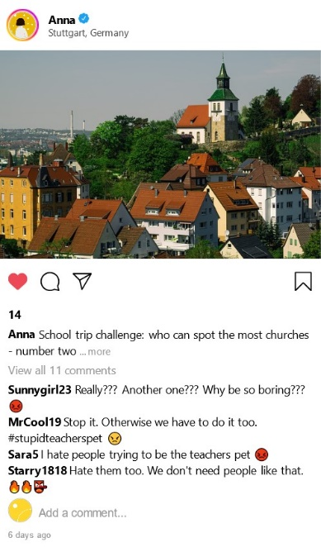
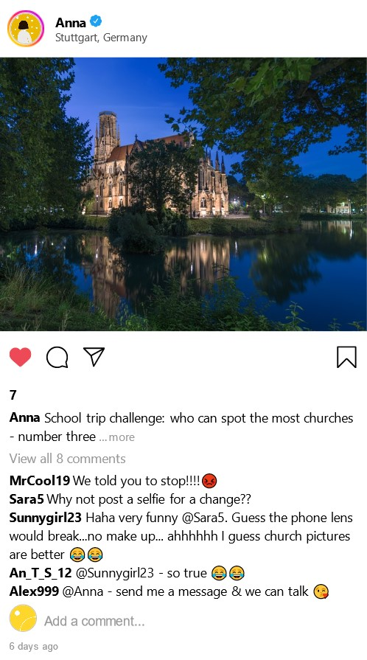
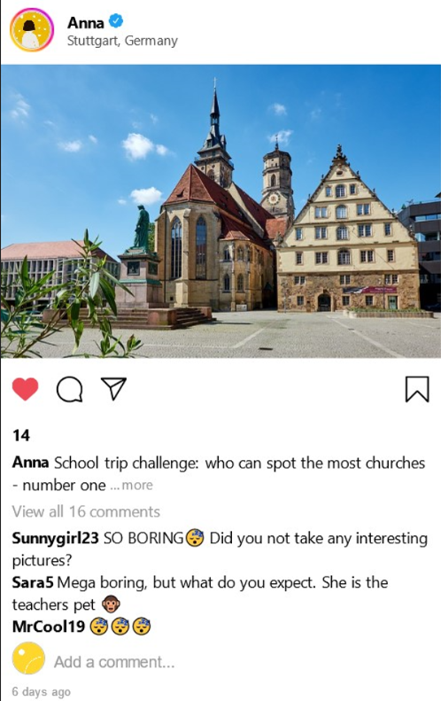

Note
Printable versions of the Instagram posts can be found at the end of the document.
If you want to create fake Instagram posts, fake WhatsApp post etc. for educational purposes such as this game, you can use www.zeoob.com .
You could for example adapt the provided chats to suit your group. Use images from your own city or maybe from a recent trip you did with your group.
Or you could spilt your group in half and have one half adapt the escape room for the other half of the group. We have made the experience that the students enjoy being involved in the creation process and this is also a very good way of getting into discussing the topic ‘cyberbullying’.
Clue to find:
So now the students know that some of Anna’s classmates have been posting mean comments on Instagram. They also find out, that Alex999 has suggested that Anna gets in touch. They should now make the connection that the second missing student is Alex and that it is very likely, that ‘Alex999’ is Alex.

RIDDLE Number four – find Alex’s seat in the classroom
Preparation
1) (Seating plan has already been hidden for riddle number 2)
2) Place a jacket over the chair.
RIDDLE Number five & RIDDLE Number six – find the note
Preparation
1) Place a hand written note inside of Alex’s jacket (use two different hand writings). This is a piece of paper, which Anna and Alex have been using to write each other messages. The front side has the QR code and the time for the doctor’s appointment.
Write the messages that Anna and Alex have been writing each other with the UV pen. (So the writing is actually not visible).
2) Set up the email address and set the automatic response.
Frontside (riddle number 5):
QR code: create a QR code (this should lead to a local doctors office)
Next appointment: (use the date of the day you are doing the game and the time of the game)
This explain where Alex is.
Backside (riddle number 6):
Hi Anna, how are you today? You did not get back to me after I told you to send me a message. Alex
Dear Alex, I am so upset, I don’t know what to do. They are doing it again. All my posts are full of hurtful comments. What should I do? I cannot delete the posts as the pictures are part of the school project and I get extra points for that. And as you know, I need the extra points, otherwise I will not pass this class. But every time I come to class, I have the feeling, that everyone hates me. They all give me funny looks, point at me and laugh. Then I start crying and they laugh even more. From Anna
Hi Anna, that sounds really bad. I might have an idea. Do you remember the leaflet we received some weeks ago? You should contact name@email.com (insert the created email here).
Hi Alex, I might try that. Can we meet later?

Email address:
The automatic response the created email address should send out, should contain information along the following lines.
Hi there,
Many thanks for your email. I think the best way forward is to have a personal meeting. My office hours are Monday to Friday from 11:30 am to 2:00 pm. My room number is 045.
Best wishes,
Monica Caller
School Counsellor
Note:
Create a message that suits your school. You could adjust the room number, use the name of the actual school counsellor etc. It should be a general message that both Anna and all the other students could receive.
Once the students have received this email address, they know that Anna has gone to see the school counsellor.

END OF THE GAME
The students have found out that Alex is at a doctor’s appointment and Anna has gone to see the school counsellor.
Of course, they could also say that they think that Anna has gone to meet Alex somewhere as she wrote that in her last response. It does not matter what solution the students decide to choose.
The main aim of the game is to set the scene for discussing the issue of cyberbullying.

ANNEX
Printable versions of the Instagram posts
